Going Home Folder
Beginning September 9th, the Blue “Going Home” folder will go home each day and needs to be returned back to school the next day. The students will keep them in their mailboxes during the day and will fill them when they are packing up to go home. The folder may contain notes, finished work, unfinished work that needs to be completed. It is important that the folder is emptied out and returned to school daily. If you are sending in money to school, please label the money in the envelope with the child’s name, teacher’s name, and what the payment is for.
Powerschool
Regular letter grades are given in 3rd grade; parents will have access to Powerschool (the teacher gradebook). You will be able to see grades as well as missing assignments and test scores. Please try to check this periodically.
Agenda
Both my 2nd and 3rd graders will be receiving an agenda to record daily assignments and other important information. Students will be writing in their assignments from a PowerPoint slide each morning. This is where all assignments will be written, and checked off as completed. If they are not checked off as completed, they will be coming home as “homework” to be completed at home to be turned in the next day. This will also serve as an important communication tool between home and school. It is important that parents review and discuss the agenda with their child each night. Parent initials are required at the bottom of each day’s agenda indicating that you are aware of the assignments and that your child has completed the work.
Newsletters
These will come home only when something needs attention or something important is coming up. Other communication can be handled with emails or the agenda. Those of you that signed up for the Classroom Dojo will be informed of special events/assignments through this tool. Photos of activities will be posted on the 3rd grade Shutterfly account listed on the front page of this handout.

Snack Policy – Peanut Free/Nut Free Snack List
Avoid snacks that contain peanuts, peanut flour, peanut oil or peanut butter or other nuts. This includes snacks with almonds, coconuts, sunflowers, filberts, Brazil nuts, cashews, hazel nuts, macadamia nuts, pecans, pine nuts, pistachios, and walnuts (tree nuts). Kellogg’s, Keebler, General Mills, Betty Crocker, and Quaker Oats brands are excellent at calling out allergens in a box: Example: Contains Peanut and Egg Ingredients.
Thank you for your consideration/support in keeping the food-allergic children safe from having a life-threatening allergic reaction at school.
- HEALTHY SNACKS (Daily classroom snacks)
- Fruit/Vegetables
. Any fresh fruit (apples, oranges, bananas, grapes, pears, plums, clementines, strawberries, melons, berries, etc.)
. Raisins, Craisins and other dried fruits
. Fresh vegetables (carrots, celery sticks, grape tomatoes, cucumber slices, broccoli, pepper strips, etc.
- Cheese/Dairy
. String cheese or other cheeses (1 oz.)
. Kraft Handi-snacks with cheese (with red sticks)
**Be careful with any other type of pre-packaged cheese and cracker sandwiches as most contain nuts/traces of nuts.
- Crackers/Snack Items
. Triscuits, Wheat Thins, Vegetable Thins (all flavors)
. Ritz crackers/dinosaurs/sticks (NOT Ritz bits or sandwiches)
. Ritz Crackerfuls (Classic Cheddar, Four Cheese, Garlic Herb)
. Town House, Club, Toasteds
. Cheez-its, Cheese Nips, Better Cheddars
. Saltines, Oyster crackers
. Wheatables, AirCrisps, Munch’ems, Keebler Snack Stix
. Kashi Tasty Little Crackers (TLC)
. Breton brand crackers
. Goldfish crackers
. Annie’s Bunnies
. Graham crackers, Graham cracker sticks
. Teddy Grahams or Teddy Graham character brand
. Animal crackers (Austin Zoo, Barnum)
. Vanilla wafers
. Cereals
Please note: Food labels/ingredients may change over time, so it is always recommended that you read the label before purchasing snacks. Please read labels carefully to make sure that products are nut free. This includes labels that read “May contain traces of peanuts/nuts”.
Homework
Homework is an important tool that reinforces skills taught in the classroom and to extend concepts, teach responsibility, and help students to develop good study habits. Typical homework items may include: incomplete work from the school day, reading and math practice activities, and of course, daily at-home reading. Please note that if your child is coming home with a lot of homework, this means that he/she is not using their time wisely in class.
Book bags will be coming home with students on Mondays with 2-3 books for them to read at night to work on their fluency. There will be a comprehension sheet for them to fill out and return on Fridays – and this will count as a grade. I cannot stress the importance of reading at home enough. Studies show that reading 15-20 minutes per day increases a person’s vocabulary and knowledge levels at a staggering amount that simply cannot be ignored.
Late/Missing Work
If your child had a difficult time with their assignment, it is their responsibility to talk to me so that I can provide them with help. If the assignment is turned in one day late and they have talked with me, it will be graded normally. If they have not talked to me, the grade will be lower. If an assignment is later than 3 days late, you will be hearing from me and we will figure out what is going on. I try my best to not give a zero for an assignment and will do whatever is needed to work with both you and your child to make sure that this does not happen.
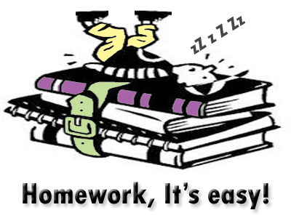
Class Rules
Following the rules in the classroom are important – this helps students be better prepared for the real world where they will be expected to follow established rules and laws. I have gone over the rules with the students and they are very basic ones – be kind, listen when others are speaking, make good choices, do your best, and follow directions.
Since providing a positive atmosphere in the classroom is very important, we will be using the school-wide behavior system, PAWS. Our school-wide behavior plan is designed to teach students to be respectful, responsible, be safe, and have a great attitude that makes them want to be the best that they can be. It’s all about making right choices!
In addition to that, the class will be able to reap the benefits of good behavior and participation in their specials and at lunch/recess with our points as well as PAWS cards given to us by others. Individual students will be able to get tickets from me for the points that they accumulate on Class Dojo (1 ticket for 10 points, 2 for 15, and 3 for 20 to be placed in the incentive jar for weekly drawings) and cards given out by other teachers and/or staff members.
Consequences result from poor decision making and will be addressed by losing points on Class Dojo, missing recess, writing a note home to parents, having to complete unfinished work during play/recess time, and lastly, a visit to Mr. Viviano.
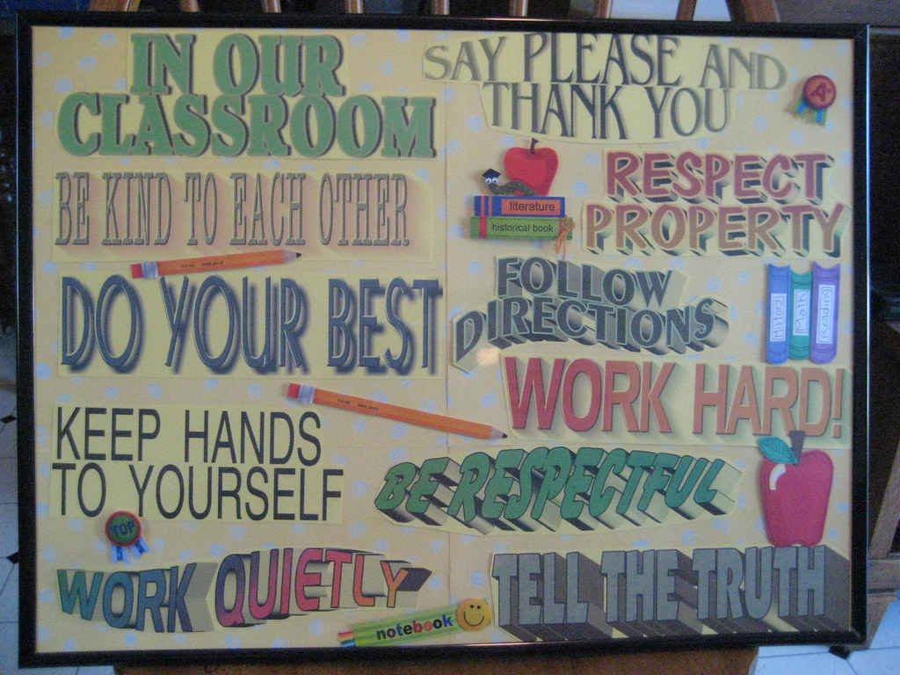

Common Core
Reading: Both 2nd and 3rd Grade
- Reading: improve reading levels, accuracy, fluency and comprehension
- Learn reading strategies to help with reading
- Use Benchmark Literacy
Math: 2nd Grade
- Deepening Addition/Subtraction Fact Strategies to 100
- Please Value
- Measurement
- Geometric shapes
- Applying place value understanding to add/subtract within 1000
Math: 3rd Grade
- Addition/subtraction of whole numbers using place value
- Developing multiplication and division operation sense
- Multiplication and division reasoning strategies
- Using geometric attributes
- Understanding and comparing fractions
- Measurement
Writing: Both 2nd and 3rd Grade
- Narrative
- Opinion
- Informational/Research
- Basic sentence/paragraph
Science: Both 2nd and 3rd Grade
- Weather, Climate, and Natural Hazards
- Structure and Properties of Matter
- Plant and Animal Relationships
Social Studies: 2nd Grade
- Where We Live
- Working Together
- Our Earth
- Our Country Today
- Our Country Long Ago
- People and Places in History

Social Studies: 3rd Grade
- Michigan (geography, economy, history, government, public issues facing the state)
- History of Native Americans and The First Europeans

Lunch from 11:00-11:45 (Recess first)

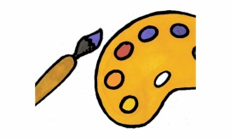
MONDAY: Art 9:55-10:35
TUESDAY: Media 9:55-10:35
WEDNESDAY: Music 9:55-10:35
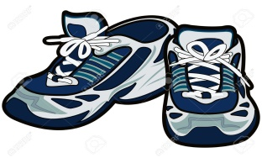
THURSDAY: PE 9:15-9:55
FRIDAY: STEM 9:55-10:35

Bathroom/Drinking Fountain Procedures
Students are welcome to use the bathroom or the drinking fountain (water bottles) at any time…with the exception of during whole class instruction/discussion or during a test. (Unless it is an emergency) Water bottles are allowed if they have a non-removable cap – we have a water bottle station next to the drinking fountain that they are welcome to keep their water bottles at. This will eliminate any chance of an accidental spill that could damage your child’s (or another child’s) work and supplies.
Book Orders
I will be submitting book orders about once per month through Scholastic. You are welcome to use the student flyers that come home or go online to order using my code which is scholastic.com.bookclubs My code is FMLN9. Any payment for orders with the flyers can be cash or a check made out to Scholastic. Please do not write me a check – I cannot accept it. If you order online, you are able to use your debit/credit card to pay for the order.

